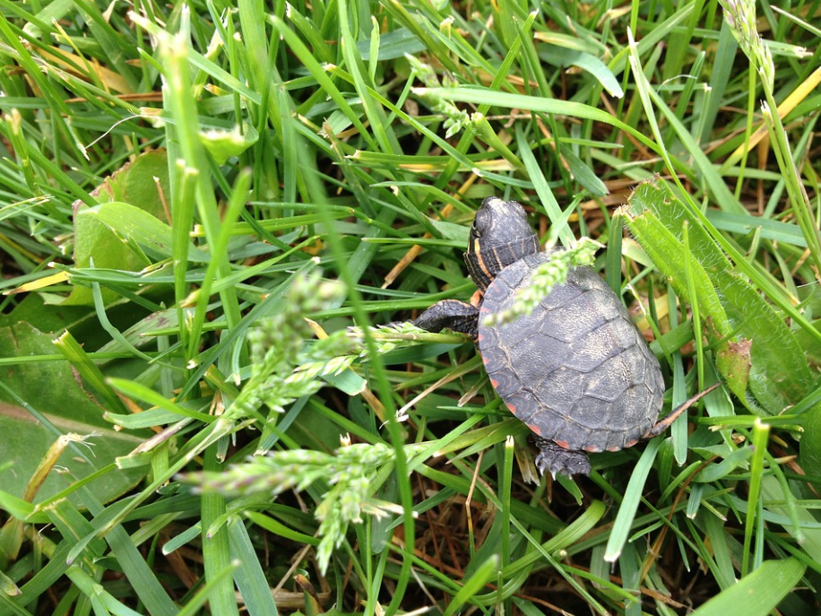

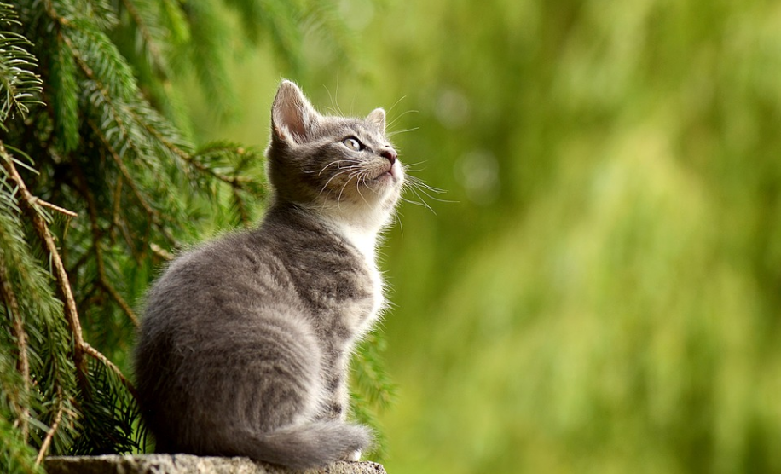

**Names:** Noris

**Age:** 2 months

**Species:** Turtle

**Size:** Small – but will continue to grow

**Colour:** Green

**Personality:** Shy and Calm

**Description:** Noris is a very cool, calm and collected turtle. He is not fussed by loud noises or humans and will just continue to go about his own ways. He is a bit lazy so you won’t lose him!

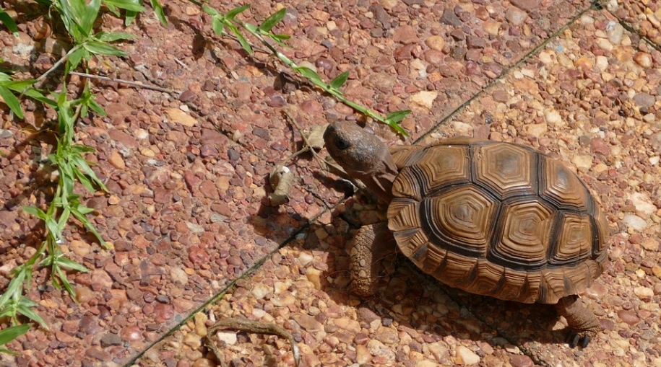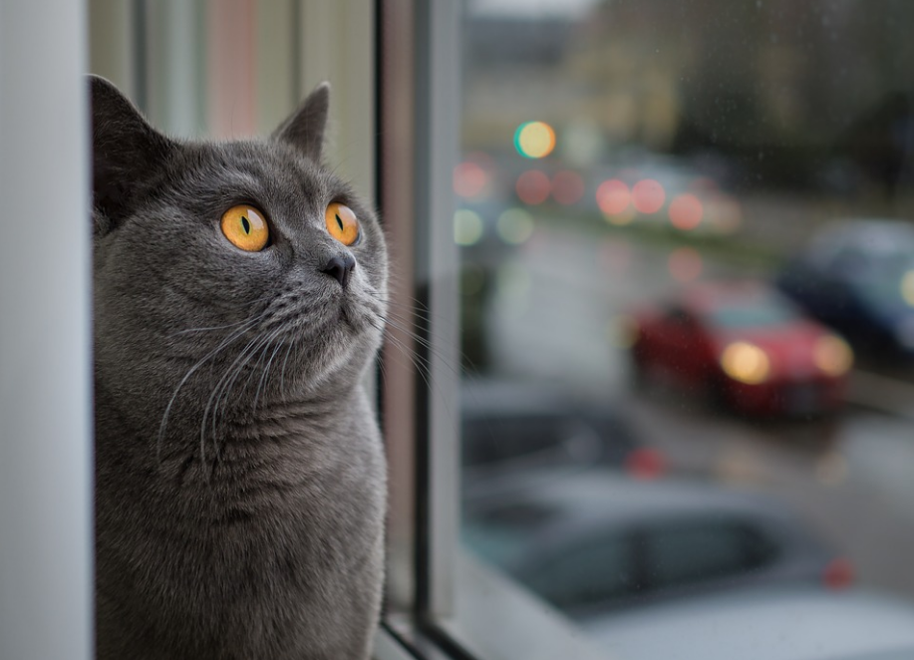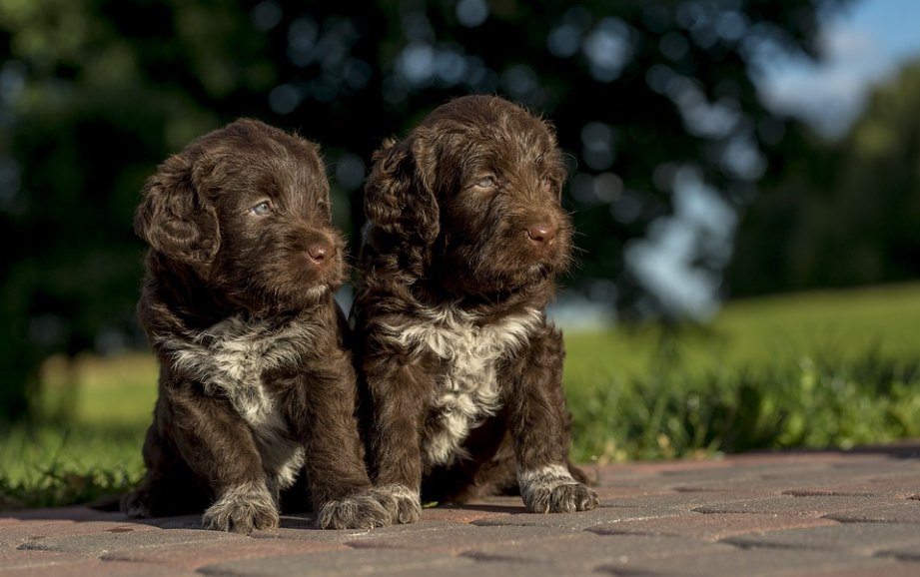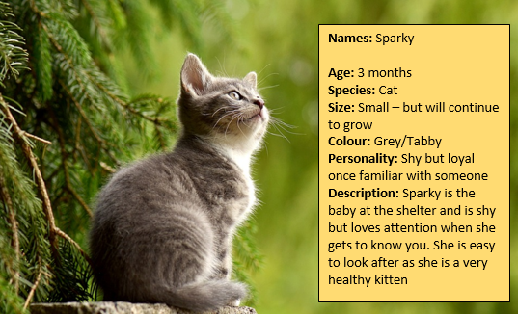

**Names:** Tilly & Max

**Age:** 6 months

**Species:** Dog

**Size:** Small – but will grow to a medium size

**Colour:** Chocolate Brown

**Personality:** Care free and playful

**Description:** Tilly & Max are the perfect puppies for families. They are young, fun and love playing around with kids. They have both taken a liking to squeaky toys.

**Names:** Sparky

**Age:** 3 months

**Species:** Cat

**Size:** Small – but will continue to grow

**Colour:** Grey/Tabby

**Personality:** Shy but loyal once familiar with someone

**Description:** Sparky is the baby at the shelter and is shy but loves attention when she gets to know you. She is easy to look after as she is a very healthy kitten

**Name:** Steve

**Age:** 9 months

**Species:** Dog

**Size:** Small

**Colour:** Cream

**Personality:** Excitable and playful

**Description:** Steve loves to play and gets excited anytime a human comes near him. However he is easy to calm down and does play nicely with kids. He is little and won’t grow much more.

**Name:** Harry

**Age:** 1 year

**Species:** Cat

**Size:** Medium size

**Colour:** Grey

**Personality:** Casual and easy

**Description:** Harry is a very easy pet to have. He doesn’t demand any more than the necessities all animals need. Harry will sleep anywhere and eat any type of food. He is great with all ages, from kids to the elderly.